EENG 284 – Digital Design

Testbench – Do Files

# Objective

The objective of this lab note is to help you understand the syntax and purpose of a DO file.

**Setting up simulations**

I find setting up the testbench waves to be a pain, especially when you are making a lot of mistakes and need to rerun your simulation multiple times; each time setting up the waveforms. In order to simplify the process of setting up the waveforms, you can write a script files that performs the waveform setup and then call the script file inside ModelSim. The script file is called a “do” file. They are very easy to make and will save you time. If a do file is provided to you, you will most likely need to edit it because your signal names may be different.

In the discussion below I have used two placeholders: <labName> is the name of your testbench module. <projectDirectory> is the system path to your Verilog files corresponding to your project.

* If provided, download “<labName>_tbWaveSetup.do” into the: <projectDirector>\simulation\modelsim
* If a do file is not created, you can use the template provided in Listing 1 as a starting point to make one for yourself. Make sure to put the do file in the directory: <projectDirector>\simulation\modelsim
* Open <labName>_tbWaveSetup.do file using Notepad. The syntax is pretty straight forward and corresponds to the text displayed in the ModelSim console window when you add or modify waveforms.
* From Quartus, you need to:
  + Make sure that your testbench is the top-level. Do this in the Project Navigator, select File view and then right click on the file testbench and select “Set As Top Level Entity”
  + Launch the simulation. Do this by selecting Tools -> Run Simulation Tool -> RTL Simulation
  + This will launch Model Sim for your testbench
* From Model Sim, you need to:
  + Maximize the Model Sim window – this makes it easier to see all the subwindows.
  + In the library subwindow, open the **work** library
  + Right click on your testbench and select Simulate
  + In the console area of ModelSim (shown in the image below) type:

VSIM 3> do <projectName>_tbWaveSetup.do

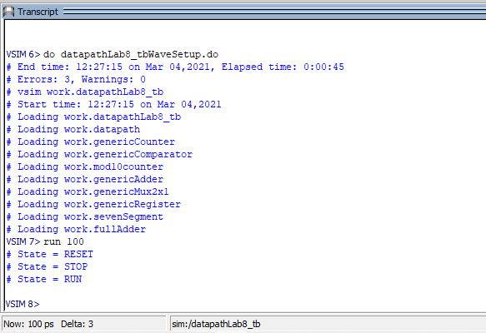

* You can type “run <time>” in this area (as shown) to simulate some amount of time. I found this VERY handy when debugging my Verilog code.
* Also note that the console has tab completion. This allows you to type the first few characters of a command/filename and press Tab to fill in the rest of the command/filename. If there is more than one choice, the command/filename will be completed up to the ambiguity.

# Example do file for hiLow Module:

* Run the testbench for the hiLow module provided on Canvas. Produce a timing diagram with the following characteristics. Zoom to fill the available horizontal space with the waveform. Color inputs green and outputs red. Order the traces from top to bottom as
  + t_seedSwitch unsigned green trace
  + t_guessSwitch unsigned green trace
  + t_playSwitch unsigned green trace
  + t_randBut default green trace
  + t_hiLowBut default green trace
  + <LFSR output> unsigned yellow
  + t_randNum hex red trace
  + t_randDisp hex red trace
  + t_hiLowSeg hex red trace
  + t_greenLEDs default red trace
* The do file for this testbench is shown in Listing 1. From top to bottom the sections are as follows.
  + Any line that starts with a “#” is a comment. The URL is a complete reference for do file syntax.
  + The restart command resets the simulation. I included this because I sometimes like to rerun the same simulation multiple times. This isn’t particularly useful for combinational logic circuits.
  + The delete wave command removes any waveforms that may have been added previously. Again, I included this because I sometimes like to rerun the same simulation multiple times
  + The add wave command puts a signal into the waveform viewing area. There are two parameters included which you will find helpful.
    - Radix changes what base the waveform value is displayed.
    - Color changes the color that the waveform is displayed.
* Once you have created the do file, you call it by running it from the console area using the do command discussed previously.
* You can advance the simulation time using the run command discussed previously.

Listing 1: do file for hiLow_tb.

####################################################################

#run this file by typing the following in the modelSim command window

#do hiLow_tbWaveSetup.do

#Useful manual: https://www.microsemi.com/document-portal/doc_view/136364-modelsim-me-10-4c-command-reference-manual-for-libero-soc-v11-7

####################################################################

restart -f

delete wave *

add wave -position end -radix unsigned -color green sim:/hiLow_tb/t_seedSwitch

add wave -position end -radix unsigned -color green sim:/hiLow_tb/t_guessSwitch

add wave -position end -radix unsigned -color green sim:/hiLow_tb/t_playSwitch

add wave -position end -color green sim:/hiLow_tb/t_randBut

add wave -position end -color green sim:/hiLow_tb/t_hiLowBut

add wave -position end -radix unsigned -color yellow sim:/hiLow_tb/uut/randNum

add wave -position end -radix hex -color red sim:/hiLow_tb/t_randDisp

add wave -position end -radix hex -color red sim:/hiLow_tb/t_hiLowSeg

add wave -position end -color red sim:/hiLow_tb/t_greenLEDs